***Technical University of*** ***Cluj-Napoca***

***Automation and Computer Science Faculty***

***Automation and Applied Informatics***



**Student:** Zigler Alexandru **Coordonator:**

**Grupa:** 30113Assist. Eng. Dan Gota

2019-2020

Cuprins

Descrierea piesei……………………………………...……………………………..………………………………..3

Comenzi utilizate……………………………………………………………………….……………………………..4

Descrierea piesei

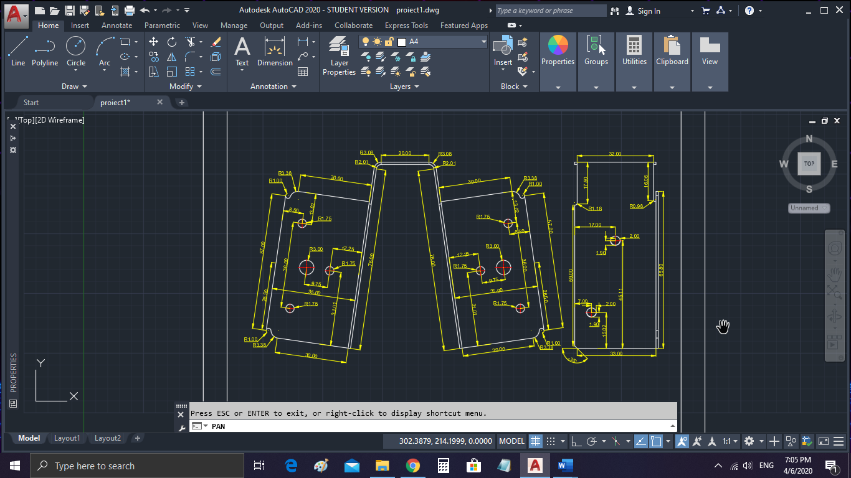

Comenzi utilizate

* UCS
* SNAP
* GRID
* ORTHOMODE
* OBJECT SNAP TRACKING
* OBJECT SNAP
* LINE
* CIRCLE
* ARC
* ELLIPSE
* RECTANG
* CHAMFER
* FILLET
* MOVE
* ROTATE
* ERASE
* COPY
* MIRROR
* SCALE
* TEXT
* DDPTYPE
* LENGHTEN
* STRETCH
* TEXTSTYLE
* LAYER
* CLAYER
* PROPERTIES
* PAN
* DIMALIGNED
* DIMANGULAR
* DIMRADIUS
* DIMLIN
* DIMSYLE